**Deep Learning and Neural Networks**

Home Task 04



**Muhammad Shakaib Arsalan**

**Student ID: F2022266626**

**Course Code: CS4152**

**Section: V2**

**Topic: Multi-Class Classification Using Feedforward Neural Networks in PyTorch**

**Resource Person: Dr. Tayaba Anjum**

School of Systems and Technology

UMT Lahore Pakistan

**Objective**

The objective of this assignment was to design, implement, and evaluate a feedforward Neural Network (NN) using PyTorch for a multi-class classification task. The aim was to observe the performance of the network in terms of loss reduction and accuracy improvement across different configurations—varying the number of hidden layers and epochs.

**Implementation**

* Framework Used: PyTorch
* Model Type: Feedforward Neural Network
* Task: Multi-class classification
* Dataset: 🔗[Fashion MNIST](https://www.kaggle.com/datasets/zalando-research/fashionmnist)
* Evaluation Metrics: Training loss, training accuracy, training time

**Different Configurations**

Experiments can conduct under the following configurations:

1. One hidden layer, 5 epochs

🔗[.ipynb File Link](https://drive.google.com/file/d/1d-njItZQsJuSMKv3eiYPxv7AzeWXNpT4/view?usp=sharing)

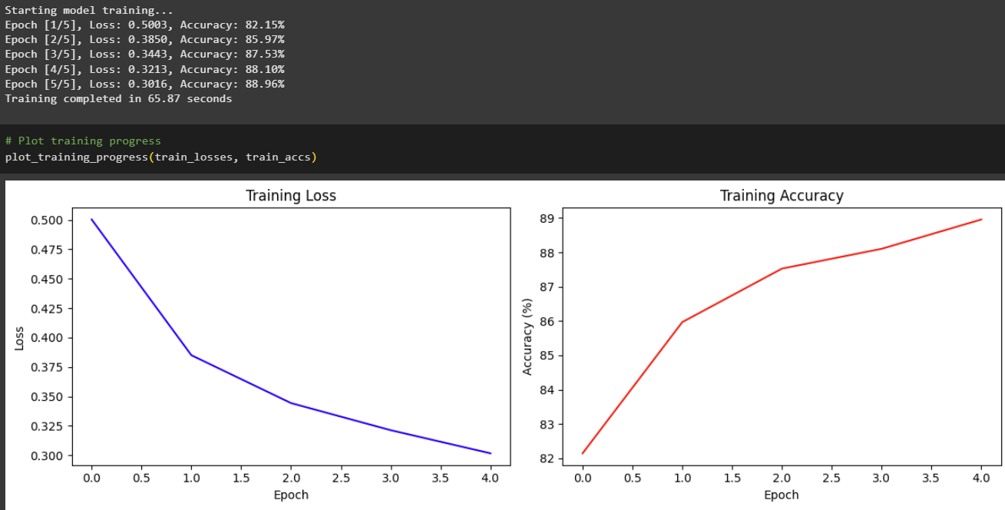

1. One hidden Layer, 10 epochs

🔗[.ipynb File Link](https://drive.google.com/file/d/1GuQXFr-AYyv-iHzT1Rfa_SeZefj3qthB/view?usp=sharing)

1. Two hidden layers, 5 epochs

🔗[.ipynb File Link](https://drive.google.com/file/d/1hMAoTPmYkY92NLy-F4UrrAhA2gVffbLo/view?usp=sharing)

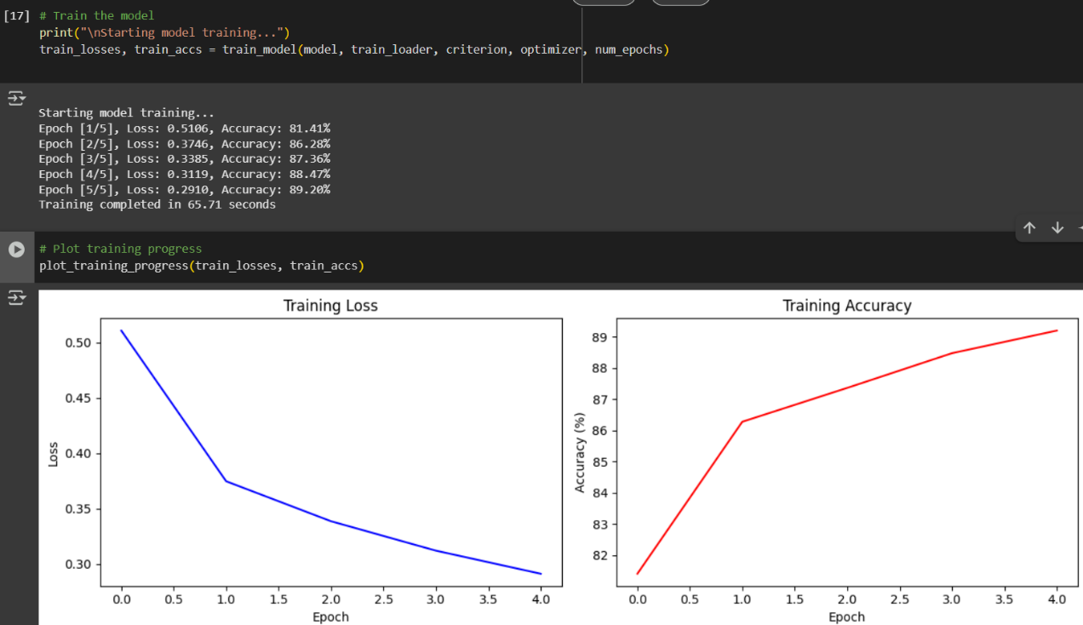

1. Two hidden layers, 10 epochs

🔗[.ipynb File Link](https://drive.google.com/file/d/1LEy_QDfNP4gSKR8OhWkw5DyyXXKo_Xll/view?usp=sharing)

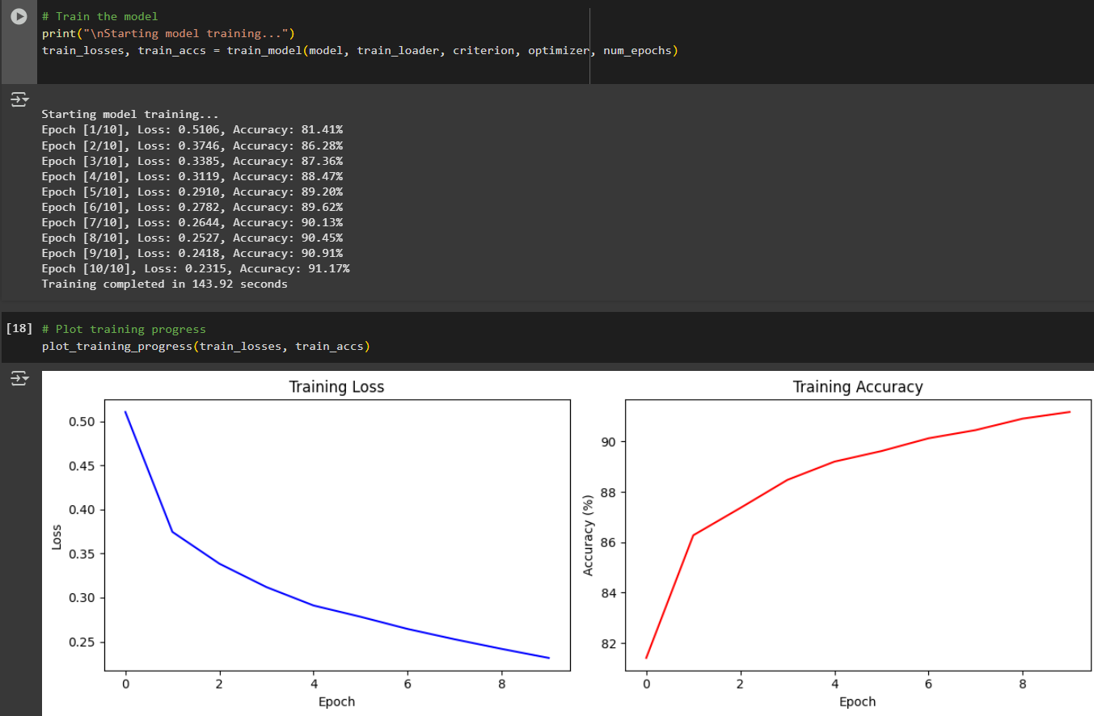

1. Three hidden layers, 5 epochs

🔗[.ipynb File Link](https://drive.google.com/file/d/1GqcEPBtjLxnx0dTSkb-NC475CAjOh3zY/view?usp=sharing)

1. Three hidden layers, 10 epochs

**🔗**[.ipynb File Link](https://drive.google.com/file/d/108o7vqRQkwWv-_9uWwAcR2u4LNe6B0U3/view?usp=drive_link)

|  |  |  |  |
| --- | --- | --- | --- |
| **Configurations** | **Final Loss** | **Final Accuracy** | **Training Time (s)** |
| 1 Hidden Layer, 5 Epochs | 0.3016 | 88.96% | 65.87 |
| 1 Hidden Layer, 10 Epochs | 0.2425 | 91.10% | 123.80 |
| 2 Hidden Layers, 5 Epochs | 0.2910 | 89.18% | 70.66 |
| 2 Hidden Layers, 10 Epochs | 0.2315 | 91.17% | 143.92 |
| 3 Hidden Layers, 5 Epochs | 0.2950 | 89.09% | 78.51 |
| 3 Hidden Layers, 10 Epochs | 0.2349 | 91.02% | 132.40 |

**Results Summary**

**Analysis**

* More epochs (like 10 instead of 5) helped the model learn better and gave higher accuracy.
* Using more hidden layers (like 2 or 3) gave only a small improvement in accuracy.
* The best accuracy was 91.17% with 2 hidden layers and 10 epochs.